

ECE 445

Spring 2018

[*Electronic Automatic Transmission for Bicycle*](https://courses.engr.illinois.edu/ece445/projects.asp)

Individual Progress Report

Tianqi Liu

Team Members: Ruijie Qi, Xingkai Zhou

TA: Hershel Dave-Rege

1. Introduction

The electronic bike transmission is an electronic system that could be installed on any bike equipped with derailleurs. The system uses hall effectors to measure the speed of the bike and the RPM of the paddle. Then the microcontroller decides the optimal gear and the motor pull the cable attached to rear derailleur to switch to the proper gear. User could manually change the gear, and information such as current gear and bike speed will be displayed on a LCD screen.

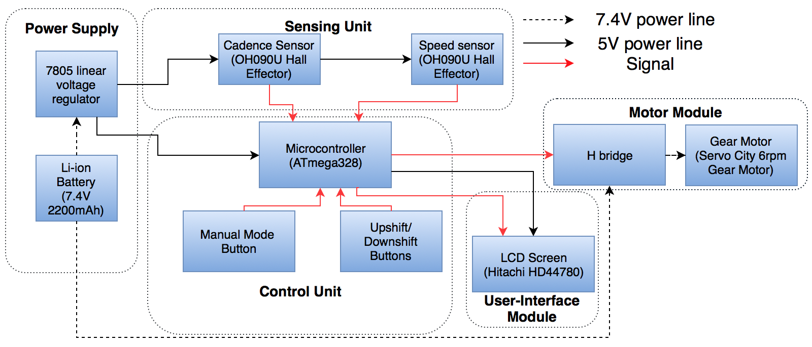

*Figure 1. Block Diagram*

In this bike transmission project, since I am an EE student with solid hardware knowledge and experience, I am responsible for a large portion of the hardware design. The bike transmission project consists of five modules: Power Supply, Sensing, Motor, Control and User Interface. I have actively involved in the development of Power Supply, Motor, User Interface Modules and Control Unit.

# 2. Individual Design Work

## Power Supply

### 2.1.1 Design Considerations

The power supply module need to safely support the whole system to operate for 10 hours. Based on the previous calculation, we decided to choose a 7.4V 2200mAh battery pack consists two 18650 Li-ion batteries, and a 7805 linear voltage regulator to supply 5V DC to microcontroller. I add a LED to show the working condition of voltage regulator. And two capacitors for denouncing purpose.

One of the safety threat in the power supply module is overheating. Based on the characteristics of linear voltage regulator, the energy waste will be:

$$(7.4-5V)*0.05A=0.12W$$

Such heat should not cause any damage.

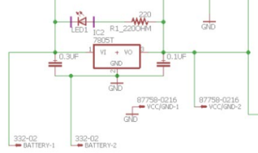

*Figure 2. Voltage Regulator Circuit*

2.1.2 Verification

The battery is not arrived yet. So I use the DC voltage source and multimeter to test the 7805 voltage regulator. First I set the DC voltage source to 7.4 V and connect to the input of voltage regulator, then I connect the output to the multimeter. The multi-meter reads 4.99V. After that, I start to increase the voltage to 10V and later decrease the voltage to 6V. Through the whole process, the output voltage is always 4.99V, which satisfy our requirement.

## User Interface

* + 1. Design Considerations

We choose the Hitachi HD44780 2*16 digits Liquid Crystal Display screen to show the current speed, cadence and gear. The size is 80mm x 35mm x 11mm, so it should be small enough to be mounted on the bike handle and also large enough to print out the information. Also, this LCD can be powered by either 3.3 V or 5V voltage source, which offers some flexibility in our circuit design. After adjust to the proper comparison using potential-meter, I use a 2200 Ohm resistor to replace the potential meter in order to simplify the circuit.

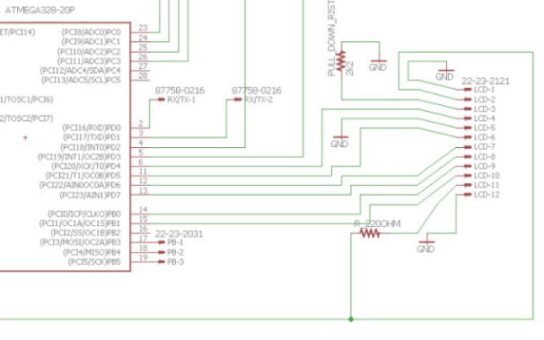

*Figure 3, LCD Circuit*

* + 1. Verification

To test the LCD, first I connect the LCD pins to digital pins on Arduino according to the online tutorial[1]. Then I write testing code that refresh the content every 100 ms. The LCD display is still clear. No observable lagging happen during the test. The test code is like:

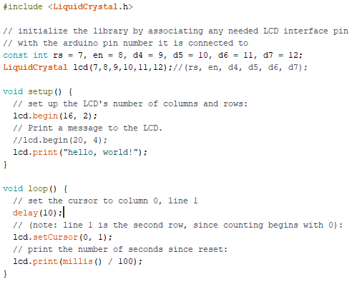

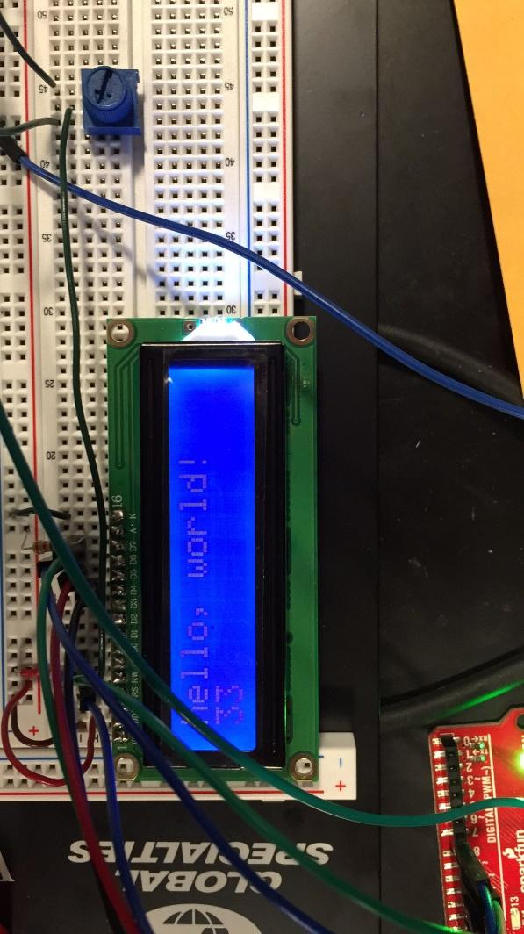

*Figure 4 LCD Bench Setting*

* 1. Motor
     1. Design Considerations

The gear motor is tested, and the ECE machine shop manufactured a motor holder so that the motor can be mounted on rare bar of the bike. They also attached the rear derailleur cable to the motor.

In the previous design, a BJT was used to amplify the current. However, we didn’t consider that motors shall be able to turn in both directions and just one BJT could not achieve that. Now we replaced it with a L298N Motor driver, which can supply 7 V, 2 A for the motor[2]. Since the maximum current of the gear motor is 0.5A, and the input voltage is 5 to 12 V[3], the motor driver should be able to safely control our gear motor. Also, the switching delay time is $0.2 μs$ for turning on and $0.7 μs$ for turning off[2], which are trivial compared the $200 ms$ motor operating time.

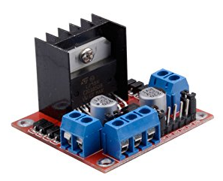

*Figure 5, L298N Motor Driver*

* + 1. Verification

Using 7 V DC power supply, the gear motor can easily pull the rear derailleur cable. Since the motor driver has just arrived, we will test it together with the gear motor tomorrow. I will use the Arduino to send 2-bit control signal to the driver, use 7.4 V DC power supply as the power supply for the driver and connect the driver output to the gear motor. The cable for rear derailleur should be attached to motor.

|  |  |
| --- | --- |
| Requirements | Validation |
| 1. Power the motor for 0.2 seconds at 7.4 V. 2. The motor should switch up or down a gear based on control signal. | 1. Set bike to lowest gear. Use hand to rotate the paddle. 2. Arduino send 01 signal for 200 ms. 3. The gear motor should rotate and pull the rear derailleur to next gear. 4. Send 10 signal for 200 ms. 5. The gear motor should return to the starting point and the rear derailleur should go back to original gear. |

* 1. PCB Design
     1. Design Considerations

In the previous PCB design, we didn’t consider the communication between microcontroller and the laptop. Now a pair of connectors are added so that the Arduino code can be uploaded into the microcontroller through RX/TX pins using UART protocol. Also, I replaced the BJT with a control signal connector to the H-bridge motor controller. What’s more, the crystal is moved closer to the microcontroller to improve its precision.

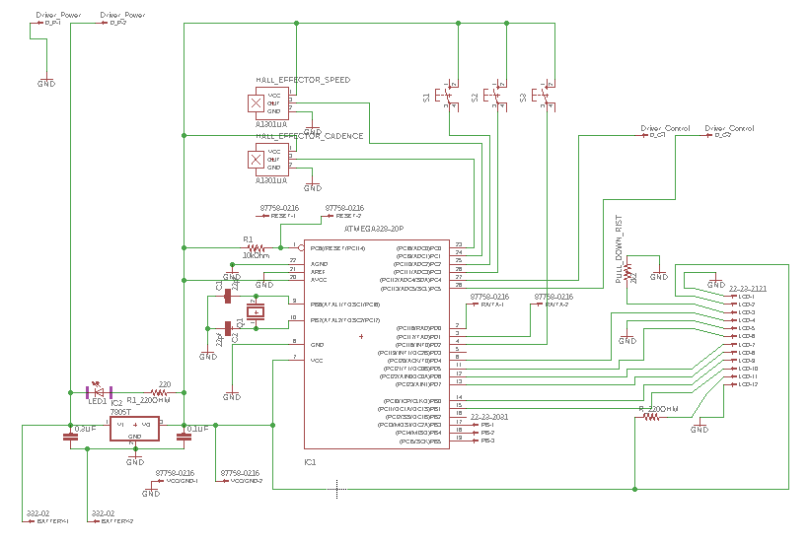

*Figure 6. PCB Schematics*

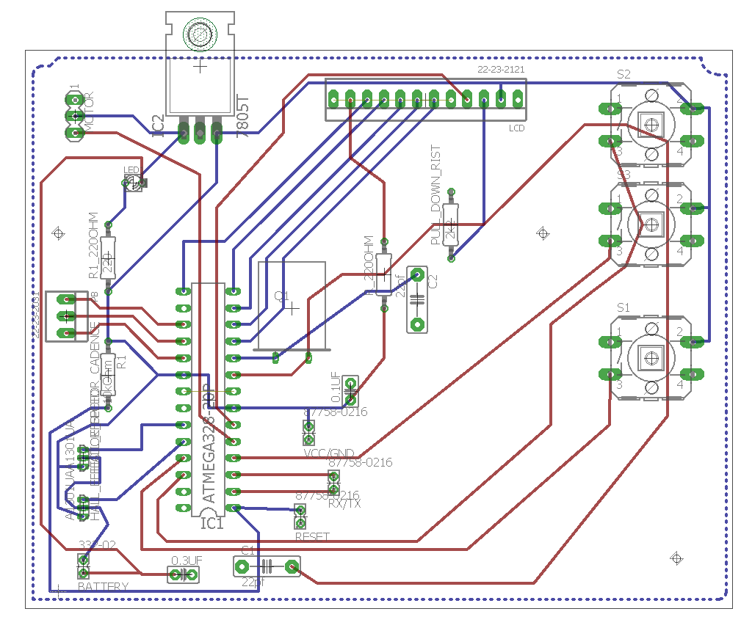

*Figure 7. PCB Board Layout*

* + 1. Verification

Since the ATmega 328 microcontroller is still on the way, it is not yet tested. Once the PCB board is ready, I will use the multimeter and probe to test it and ensure all wires are connected. Then I will solder the microcontroller on it and test the whole system.

|  |  |
| --- | --- |
| Requirement | Validation |
| wires on PCB are fully connected | 1. Set multimeter to ohmmeter mode 2. Use probe to make contact with the both ends of each wire 3. Each time a beep shall be heard |

# 3. Conclusion

Since I am the only person with hands-on experience on circuit design and hardware development, I am responsible for most of the hardware of our system. Till now, I have searched on Internet to choose the specific type of each component, tested the LCD screen and voltage regulator, designed the PCB and drew it using eagle, and involved in microcontroller programming. The voltage regulator and LCD screen are tested and proved to be fully functional. Gear motor is tested using DC power supply and mounted on the bike. Also, I have come to the machine shop several times to meet the staff in ECE Machine Shop and discuss the mechanical design of a motor holder. Compared with the schedule on our design document, I think I am following the pace in most aspects. Our team might be a little behind due to the emerging issues such as motor driver

In the following weeks, I will test the H-bridge and motor. Right now we use the Arduino Uno for software development. Once the ATmega328 microcontroller and arrived, I will boost it using the Arduino system. What’s more, I will integrate all the subsystems together on bread board to verify the correctness of our PCB design.

|  |  |
| --- | --- |
| **Week** | **Tianqi** |
| **3/26** | Test the motor module and microcontroller on breadboard before the final round of PCB order. |
| **4/2** | Install control buttons and battery module on the bike |
| **4/9** | Conduct road test and modify mechanical part and motor |
| **4/16** | Redesign and remanufacture any problematic part |
| **4/23** | Conduct 10 hour road test and fix any emerging issue. |
| **4/30** | Prepare for final demo |

According to IEEE code of ethics number 9, we should avoid injuring others, their property, reputation, or employment by false or malicious action[4]. Thus, we choose to use the motor driver module in steady of using a cheaper chip. Because the module is equipped with heat sink so that the burning possibility will dramatically decreases. Also, the battery pack we purchased is embedded with a safety chip that could cut off the circuit if current is too large.

# Citations

[1] *Arduino - HelloWorld*. [Online]. Available: https://www.arduino.cc/en/Tutorial/HelloWorld. [Accessed: 26-Mar-2018].

[2] “L298 Dual Full Bridge Driver.” ST Microelectronics, 2000.

[3] “6 RPM Gear Motor.” ServoCity.com, [www.servocity.com/6-rpm-gear-motor](http://www.servocity.com/6-rpm-gear-motor).

[4] “IEEE IEEE Code of Ethics,” *IEEE Code of Ethics*, 2018. [Online]. Available: https://www.ieee.org/about/corporate/governance/p7-8.html. [Accessed: 27-Mar-2018].